Higher Colleges of Technology



**ELE 3614: Microcontroller System**

**LAB. REPORT MANUAL**

**EXPERIMENT 1**

**LED Blinking**

**BY**

|  |  |  |
| --- | --- | --- |
|  | **Name:** | **ID** |
|  |  |  |
|  |  |  |
|  |  |  |

**Objective:**

The main objective of this experiment is to control different Leds by using PIC microcontroller (PIC16F1937) by attaching those Leds on different output Ports (PortA, PortB, PortC, PortD or PortE) of microcontroller. As in this experiment we are controlling Leds by controller so for this purpose we have to declare the Ports of controller as output or input.To declare any Port as input we have to we have to send 255(11111111) to TRISx register while to set the PORT as output we have to send 0 to TRISx register. In our case we are setting the PORTA as output by sending 0 to TRISA register. After declaration we can send any value to PortA.

In our case we are sending 0 for turning off Leds and 255 for turning on all the Leds.

**Circuit Diagram:**

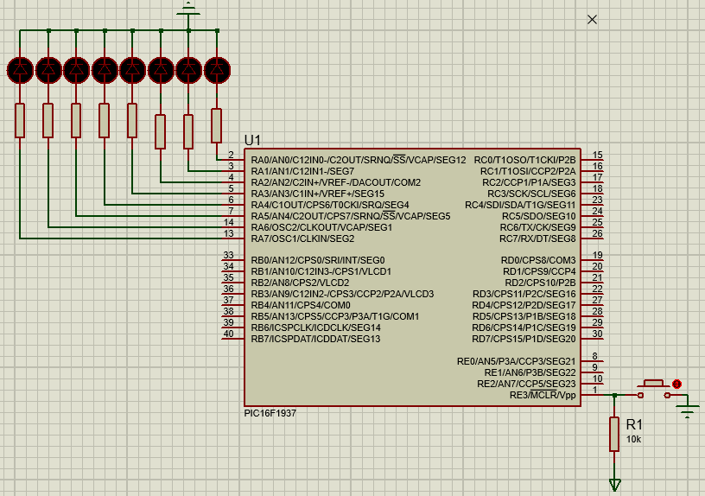

**Flow Chart:**

Leds on PORTA

PIC16F1937

Resistors

In the Circuit diagram the leds are connected with resistors and powered up via controller’s PortA. And in the flow chart the same explanation is given in the form of blocks as the code is running in the controller as hex file and leds are getting on and off accordingly. And resistors are used to control the current for leds and all resistors are of the value 150ohms.

**Code:**

void main() {

TRISA=0; //make PortA as output Port

While(1){

PORTA=255; //send high on all pins

Delay_ms(1000); //delay for one second

PORTA=0; //send low on all pins

Delay_ms(1000); //delay for one second

}}

**Code Explanation:**

All the code is written in a function named as main.In the main first of all we have decaled the PortA as output by sending 0 to TRISA register.After that in a while loop which is an infinte loop we are turning on and off the leds attached on the PortA by sending 255 and 0 respectively. And this on and off pattern is repeated with a delay of 1 second and this process will repeat infinte times.The Delay_ms is setting the time of the blinking and 1000 is showing the time in milli seconds as 1000ms is equal to the 1s.

**Resistor Calculation:**

As the leds are connected we controller and microcontroller outputs 5v on ints output pins.So this 5v is high for leds to burn out so to limit this voltage and current we use resistor with leds.As in our case the limiting current for Leds is 20mA and voltage is 2V.So the value of the resistor will be

As

Vsupply = power supply

Vforward = Forward voltage for Led

Now

R= (Vsupply – Vforward)/Current

R= (5-2)/20mA

R=150ohms

So the resistor attached with all Leds in Series will be 150ohms each.

**Observation:**

The attached Leds are blinking with the predefined delay as 1s.The six leds are blinking. As we are sending 255(11111111) for turning on leds and 0 for turning off. This blink gap can be changed esaily by changing the value after delay_ms.

All the leds are turning on and off together rather than seperately.

**Analysis and Discussion:**

Theoratically it was described that by sending 8bit value to PortA of the controller only 6 leds will be glown because 2 pins of the PortA are reserved for the Crystal oscillator. So by sending 8bit value either it may be 255(11111111) or it may be 00000000 the last two Msb bit value will not be implemented and remaing bits will be outputed to the controller’s output Port.

While when we observed it in real the same result appeared as leds are blinking with delay of 1s .In addition the current limiting resistors are attached to limit current for leds.

Also the blinking of Leds entirely depends upon the value of crystal attached. If the crystal value is greater then the blinking time will be less and vice versa.In our experiment we have attached the crystal value as the 19.6608MHz crystal.

**Conclusion:**

In conclusion we can say that any output device like leds, bulbs, relay or any other output device can connected and controlled by the microcontroller’s output Port after declartion of Ports.This controlling of leds is very useful for real world applictions like almost in all electronics devices, were indication is necessary, leds are used.The leds are the building blocks of seven segments, Led matrics and big led screen.Similarly almost in every embeded and electronics devices the controller is used and work as a brain of the devices.The examples are micrwave oven, smart power supplies ,TVs and infinitely many devices.In our experiment we have successfully shown the blinking and it has also been observed on the hardware.